**New Indian restaurant in San Francisco Bay Area**

1. **Business Understanding and Goals**
   1. 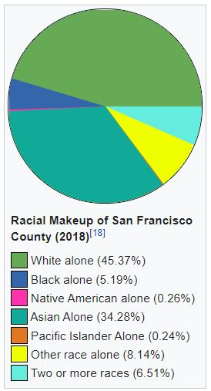**Introduction**

The **San Francisco Bay Area**, popularly referred to as the **Bay Area** or simply the **Bay**, is a populous region surrounding the [San Francisco](https://en.wikipedia.org/wiki/San_Francisco_Bay), [San Pablo](https://en.wikipedia.org/wiki/San_Pablo_Bay), and [Suisun Bay](https://en.wikipedia.org/wiki/Suisun_Bay) [estuaries](https://en.wikipedia.org/wiki/Estuary) in [Northern California](https://en.wikipedia.org/wiki/Northern_California).  [Northern California](https://en.wikipedia.org/wiki/Northern_California)'s nine-county Bay Area contains many cities, towns, airports, and associated regional, state, and [national parks](https://en.wikipedia.org/wiki/National_park), connected by a complex multimodal transportation network It is a cultural and financial center of the western United States. It has a diverse population with 2.7% of Indian Americans among 34.28% of Asian population in San Francisco city alone. Annually it attracts about 25 million visitors. This diversity and tourism provide opportunity to experience different culture and food. These statistics provides an opportunity to explore possible neighborhood in San Francisco Bay area to open an Indian restaurant.

* 1. **Problem and Goal**Even there are lot of opportunity exists, competitions are also there. In Bay area, many Indian restaurants are already in battle. To open a new restaurant is very challenging. There are many features to be considered before opening an Indian restaurant like location, indoor, outdoor dining, delivery, transport options etc. The location of the restaurant plays an important role. It should be in a busy locality as well as less competitive. The goal of this project is to identify the suitable locations to open an Indian restaurant in San Francisco Bay Area Neighborhoods.
  2. **Target Audiences**

The targeted audiences for this report are people looking to open a new Indian restaurant and anyone looking to expand their Indian restaurant in San Francisco Bay Area neighborhood.

1. **Analytic Approach**
   * Collect the San Francisco bay area neighborhood data.
   * Collect its neighborhood geolocation information.
   * Using Foursquare API we will get all the nearby venues for each neighborhood.
   * Filter out the Indian Restaurants venue for each neighborhood.
   * Visualize the Data in map using folium library.
   * Calculate the mean of all venue groups by their neighborhoods.
   * Clustering using K-means Neighborhoods.
   * Examine Clusters to find the suitable neighborhood to start an Indian Restaurant.
   * Discuss about the results and conclude.
2. **Data Requirements**

Thedata that will be required to analysis the neighborhood of San Francisco Bay Area to open an Indian restaurant are

* List of neighborhoods in San Francisco Bay Area
* Geographical location of the neighborhoods
* List of location of Indian restaurants in these neighborhoods

1. **Data Collection**

List of neighborhoods of San Francisco Bay Area neighborhood can be downloaded from

<https://data.sfgov.org/api/views/f9wk-m4qb/rows.csv?accessType=DOWNLOAD>

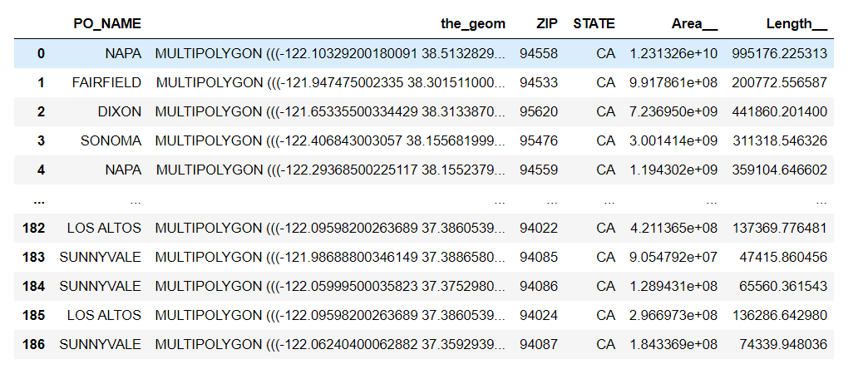

The downloaded information from above link provides the postal code, location name, state information. When accessing the link, the data is downloaded as CSV and parse through pandas library in python to derive the required information.

For each of the neighborhood from the previous CSV file, the corresponding geolocation is derived using pgeocode python library by passing their zip code.

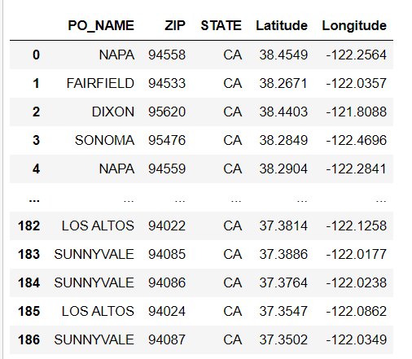

Venue data with the list of Indian restaurants in these neighborhoods are gathered using foursquare APIs by passing the geolocation.

